Your Name: ________________________________________ Your Age: __________________________

Your Goal (in hours): _______________________________ Today’s Date: _______________________

Directions: Use this form to track the total number of minutes you read. For every 30 minutes, fill in a circle. Once you complete the row of circles, you get a coupon for a free ice cream cone or slice of pizza!

=

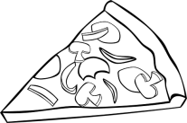 OR

